3.1 Introduction to Power BI
3.1.1 Introduction of Power BI and its Components
Power BI is a data visualization and business intelligence tool created by Microsoft. It helps us to turn raw data into easy to understand reports and interactive dashboards which non-technical users can also create easily. In this article, we will understand its key components.
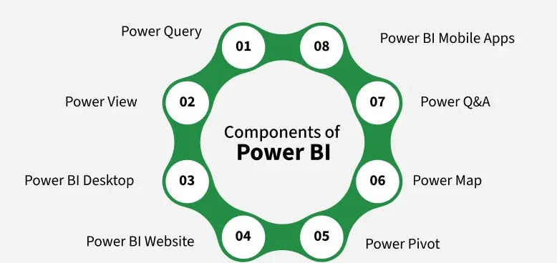

1. Power Query
- Power Query is the first step in working with data in Power BI. It allows you to connect to different data sources like Excel files, databases, web pages or even cloud-based services. Once the data is imported Power Query helps you to clean, transform and shape it into a useful format.
- We can remove unnecessary rows, change column names, combine data from multiple tables and much more all without programming using Power BI. This process is called “data wrangling" and Power Query makes it easy and visual.

2. Power View
- Power View helps us to create visuals and reports by simply dragging and dropping data fields. It support wide range of chart types like bar charts, pie charts, line charts, maps and more.
- It’s interactive which means you can click on parts of the chart to filter other parts of the report. It is mainly used to explore your data visually and discover trends. It is helpful for users who prefer to see patterns through visuals rather than numbers.

3. Power BI Desktop
- Power BI Desktop is the main platform where most of the work happens. It combines all the features like Power Query (for cleaning data), Power Pivot (for modeling data) and Power View (for visualizing data) into one tool. This is where you build complete reports and dashboards.
- This interface is user-friendly and it allows you to design everything offline before publishing it online. It is like workshop were we prepare everything here before sharing it with our team or organization.

4. Power BI Service
- After we create our reports in Power BI Desktop you can publish them to the Power BI Service which is also known as the Power BI Website. Here we can share your reports with others, collaborate in teams and access your data from any device using a browser.
- It’s a cloud-based platform that also lets us schedule data refreshes and receive automatic updates. We can also create dashboards here by pinning visuals from different reports into one view for easy monitoring.

5. Power Pivot
- Power Pivot is the engine behind the scenes that helps you work with large datasets quickly. It lets you create data models which means you can link different tables together and use formulas (called DAX formulas) to perform calculations.
- Even if you have millions of rows it compresses the data and processes it efficiently. This is great for building powerful reports without slowing down your system. It’s especially useful for users who want to do in-depth analysis.

6. Power Map
- Power Map is used when your data includes geographical locations like countries, cities or coordinates. It creates 3D maps that let you view your data based on location. You can see patterns like sales by region, customer distribution or delivery routes.
- The maps are animated and you can even show changes over time. For example, how sales grew across different areas month by month.

7. Power Q&A
- Power Q&A is like talking to your data using natural language. You don’t need to know any query language just type a question like “Show total sales for 2024” or “Top 5 selling products” and Power BI will understand and give you the answer instantly in the form of a chart or graph.
- It uses smart algorithms to understand your words and give meaningful answers. This feature makes data analysis more accessible to people who may not be experts.

8. Power BI Mobile Apps
- Power BI has mobile apps for iPhone, Android and Windows devices. These apps allow you to access your reports and dashboards anywhere and anytime. You can view the latest data, check KPIs and stay updated on business performance while traveling or during meetings.
- The mobile interface is designed to be clean and responsive so you can scroll through your visuals easily even on a small screen.

3.1.2 Building blocks and Architecture of Power BI
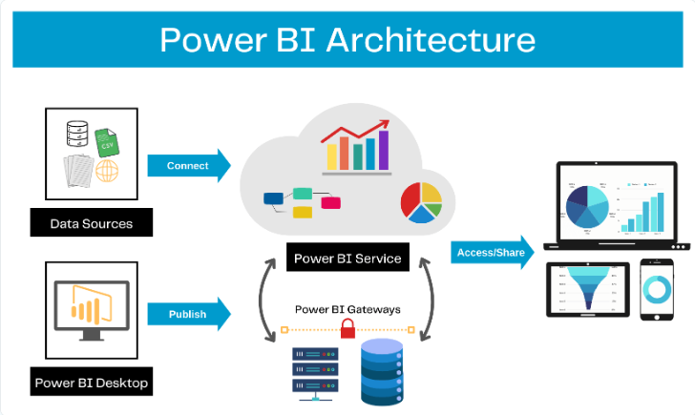
There are five Power BI building blocks which are:
1. DataSets
Dataflow’s source data or the collection of data that are imported are called Datasets. Each of these datasets is connected to Power BI to make them be stored in one single place.

2. Visualization
When the data are represented in the form of charts/graphs/diagrams/ any other form of visuals, it is called visualization. These help in reforming the data for a better understanding.

3. Reports
The visual representation of any collected data is called Reports and they include charts, maps, graphs, and even tree maps. These reports can be created in Power BI and can be shared through dashboards, with one’s friends. Another way to generate reports is when the user connects to various datasets from their SaaS applications / Excel workbooks. Report making includes 2 modes, called Reading View and Editing View.

4. Dashboards
A single sheet that consists of numerous widgets and tiles is called Dashboards. These are either created by the user himself or are borrowed from the one created and shared by their colleague in the Power BI service. In short, it is a collection of various data and reports.

5. Tiles
Each and every visual data stored in the dashboards are called a Tile. In other words, the Dashboard is a collection of Tiles.
The Power BI Architecture diagram you've shared shows how data flows and is processed within the Power BI ecosystem. Here's a breakdown of each component and the process flow as per the figure:
1. Data Sources (Left Side)
This is the starting point of the architecture. Data sources can be:
- Databases (SQL Server, Oracle, etc.)
- Excel/CSV files
- Web data or other cloud-based services
These sources are connected to Power BI to extract the raw data.
2. Power BI Desktop
- This is a development tool installed on a user's local machine.
- Users import, transform (using Power Query), and visualize data from various sources.
- After building dashboards or reports, the data is published to the Power BI Service.

3. Power BI Service (Cloud Platform)
- This is the central cloud-based platform (also called Power BI Online).
- It receives published content from Power BI Desktop.
- Users can collaborate, create dashboards, schedule data refreshes, and manage datasets here.
4. Power BI Gateways
- Acts as a bridge between on-premises data sources and Power BI Service.
- Ensures secure data transfer from internal servers/databases to the Power BI cloud.
- Used when your data resides within your organization's network and must be kept secure.
5. Access/Share (Right Side)
- Reports and dashboards hosted on the Power BI Service can be accessed or shared:
  - On desktops
  - On tablets
  - On smartphones
Users can interact with reports and make decisions based on real-time data.
Introduction and installation of Power BI Desktop
Power BI is a business analytics tool developed by Microsoft where "BI" stands for Business Intelligence. It is used to connect, visualize and analyze data from various sources. You can create interactive dashboards, reports, graphs and charts with just a few clicks. Power BI also helps with data cleaning, preparation and discovery.

Step 1: Open the Official Power BI Website
Open any web browser like Chrome or Edge and go to the official Power BI website.
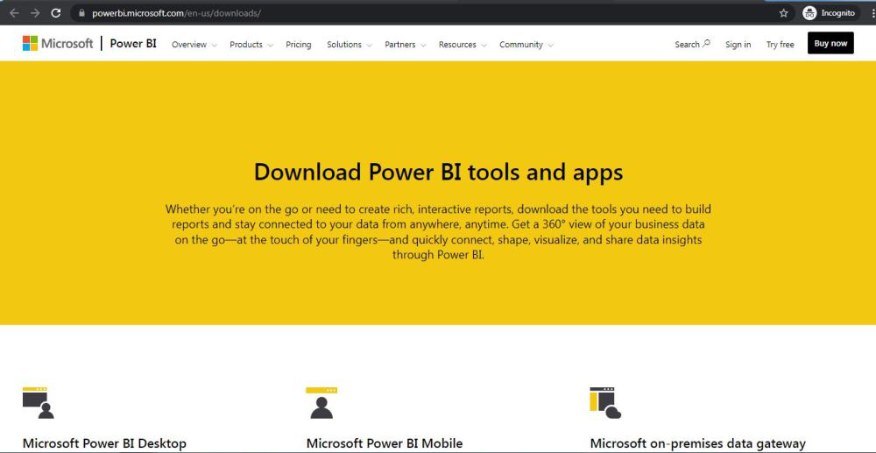
Step 2: Go to the Power BI Desktop Section
On the homepage click on the “Download Power BI Desktop” option.
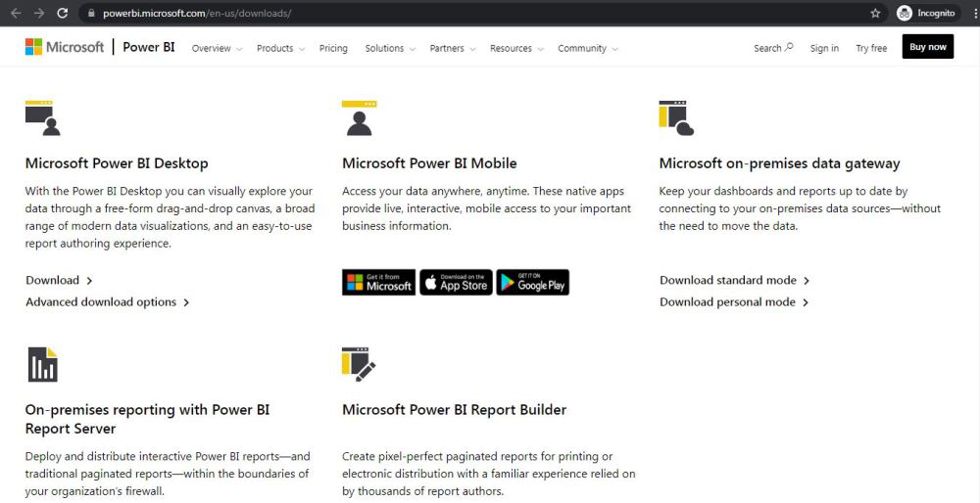

Step 3: Click on the Download Button
You will be taken to a new page. Click on the Download button to start the process.
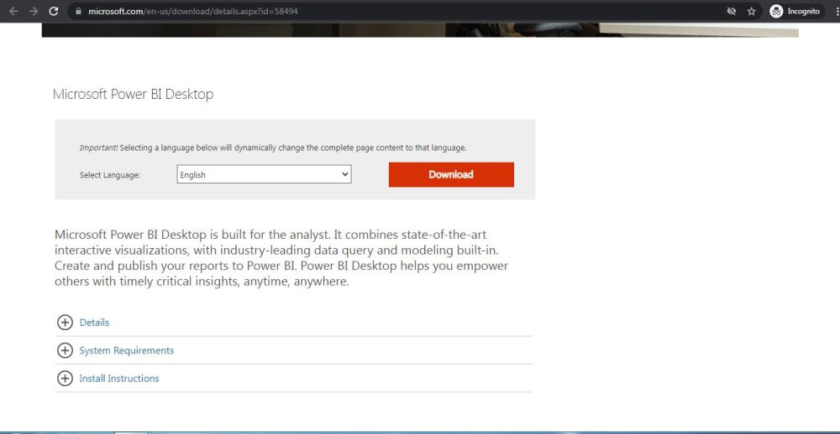

Step 4: Choose the Installer Based on Your System
On the next webpage choose the setup option according to your system configuration, let's take the first setup click on the Next button. Downloading of the executable file will start shortly. It is a big 361.7 MB file that will take some minutes.
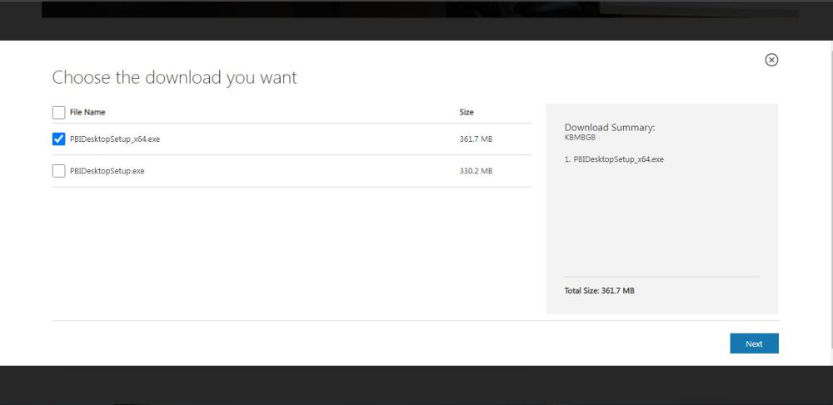

Step 5: Find the Downloaded File
Now check for the executable file in downloads in your system and run it.
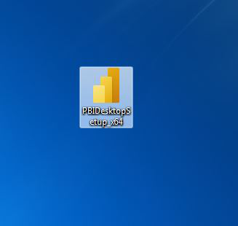

Step 6: Run the Installer
Double-click on the file. If prompted with a security warning click Run.
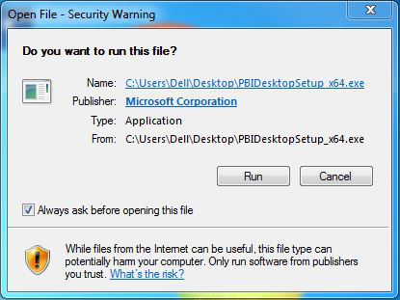

Step 7: Select Your Language
Choose your preferred language and click Next.
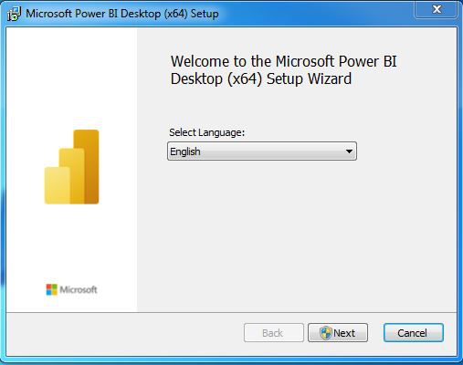

Step 8: Allow Changes to Your System
A pop-up will ask for permission to make changes to your system. Click Yes.
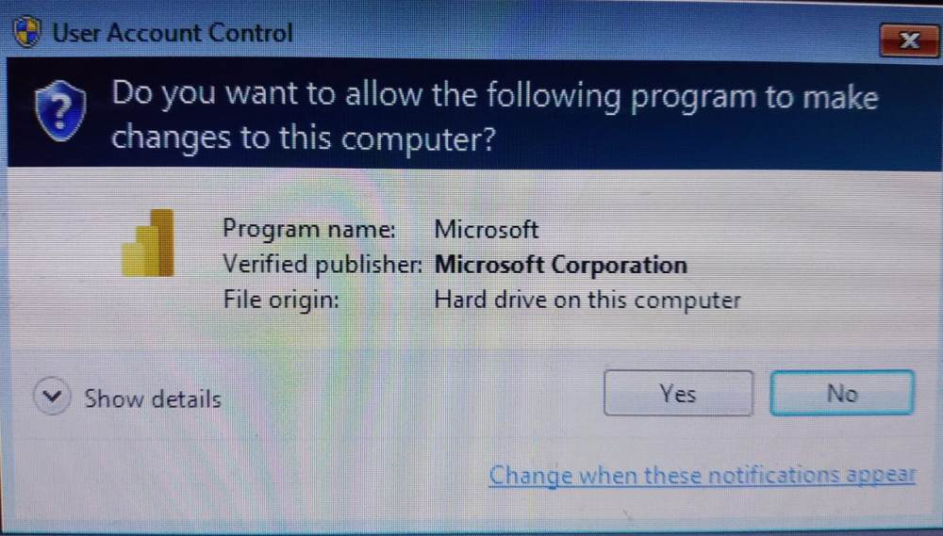

Step 9: Setup Will Start
Power BI will now begin preparing for the installation.
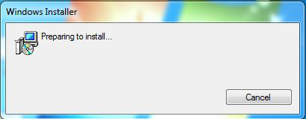

Step 10: Start Installation Setup
Click Next on the setup welcome screen.
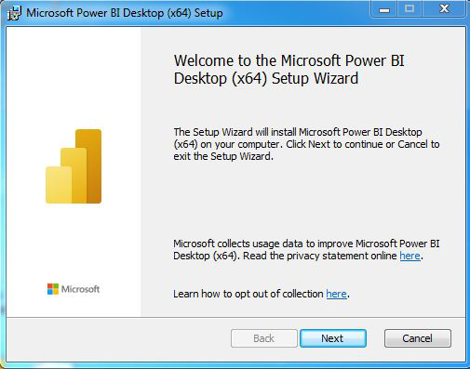

Step 11: Accept the License Agreement
Check the box that says “I accept the terms in the License Agreement” and click Next.
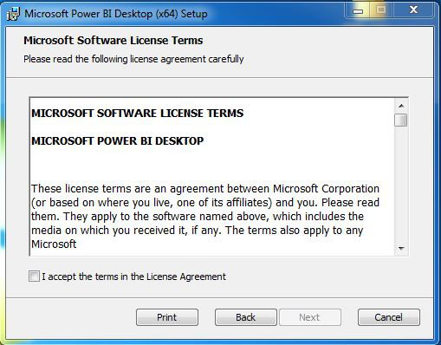

Step 12: Choose Installation Folder
You can either keep the default location or choose a different one. Then click Next.
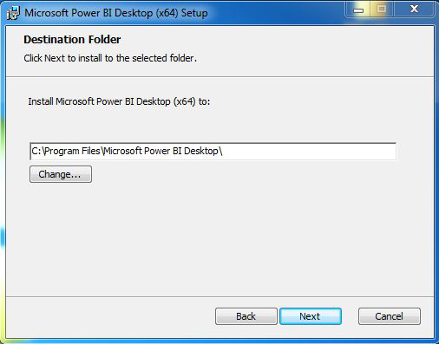

Step 13: Begin Installation
Click on the Install button. Installation will start and usually takes a minute or two.
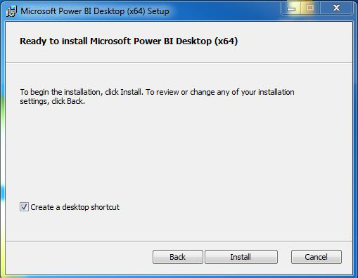
As you can see the installation is started in the below image
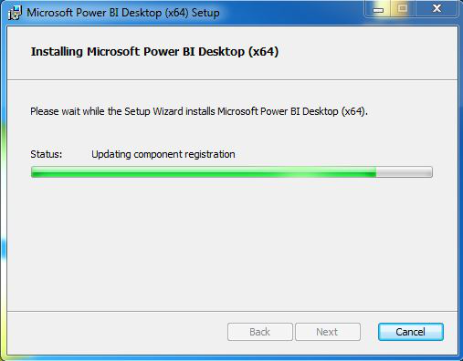

Step 14: Complete Installation
Once done click on the Finish button.
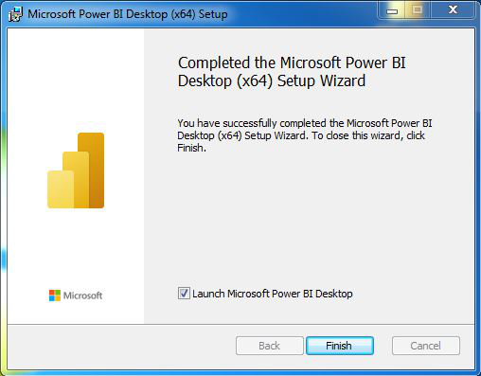
3.2 Data sources in Power BI
3.2.1 Using files (excel, pdf, csv) as a data source
3.2.2 Extracting data from folders, and databases
3.2.3 Working with Cloud SQL database and database sources
3.2.4 Connecting to Analysis Services
3.2.5 Working with Other data sources (OData, web, SharePoint)

